

User Guide
Copyright © 2005 – The University of Nottingham, Medical Education Unit

Table of Contents
Table of Contents 2
1.0 Introduction 3
1.1 Types of Assessment 3
2.0 Question Types 4
2.1 Dichotomous 4
2.2 Multiple Choice 5
2.3 Multiple Response 7
2.4 Extended Matching 9
2.5 Likert Scale 11
2.6 Ranking 12
2.7 Fill-in-the-Blank 13
2.8 Image Hotspots 15
3.0 Creating Assessments 18
3.1 Creating new Questions 18
3.2 Creating new Papers 21
4.0 Marking and Statistics 22
4.1 Introduction 22
4.2 Class Totals 22
4.3 Item Analysis 24
5.0 Searching 25
6.0 Importing/Exporting Questions 28
6.1 Exporting a Paper 28
6.2 Importing Questions 29
Appendix A – Basic XHTML tags 30

1.0 Introduction

TouchStone is a purpose-built Assessment/Survey system designed to integrate with the Networked Learning Environment VLE. It is entirely web-based to allow easy access by staff and students at any site and any computer platform. Running over secure SSL protocols the system supports four distinct types of paper: 1) formative assessment, 2) progress test, 3) summative assessment and 4) surveys.

1.1 Types of Assessment

TouchStone supports the following four types of assessments/surveys:

- Formative Assessment
Assessment paper is presented to the examinee on a screen by screen basis. When the final screen in completed a final single screen is displayed showing all the questions marked by the system and any pre-entered textual feedback from the exam writer.

- Progress Test
Assessment paper is presented to the examinee on a screen by screen basis but unlike formative assessments the final screen only confirms with the examinee that all selections and marks have been recorded by the system. This allows a number of different students to complete the test over a period of time and not to be able to determine the correct answers until some predefined time. All students who have completed a particular progress test can be emailed their marks individually by using the ‘Class Totals’ part of the ‘Statistics’ menu.

- Summative Assessment
Summative assessments for all intents and purposes can be thought of as Progress Tests, certainly in how they are handled by the system. The two types are separately provided for to allow staff to differentially code up assessments of both types and then to list them separately.

- Surveys
Surveys, like assessments, are presented screen by screen. At the end the user is told that their responses have been successfully recorded by the system. The main difference between surveys and summative assessments is that the responses to a survey are not marked. The data remains in the database so that staff may perform an item analysis and determine the number of responses per question option.

2.0 Question Types

2.1 Dichotomous

Presentation
Dichotomous type questions present a clinical scenario, lead-in and a variable number of options (or stems) to which the examinee must answer either ‘True’ or ‘False’, or ‘Yes’ or ‘No’. Depending upon the configuration of a particular question the system will support positive or negative marking and the addition of an ‘Abstain’ answer.

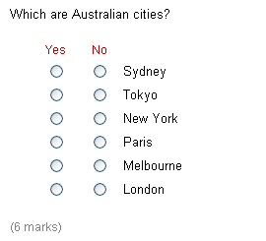
Figure 1: Six option textual dichotomous question using ‘Yes’ / ‘No’ labels.

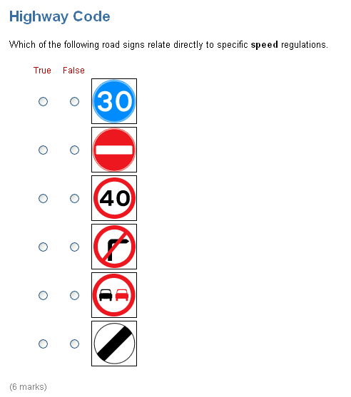
Figure 2: Six option graphical dichotomous question using ‘True’ / ‘False’ labels.

Marking

Dichotomous questions can be marked in positive or negative mode. Positive mode assigns one point to each correct option and zero to incorrect options. Negative mode, however, assigns one point to each correct option but negative one to each incorrect option.

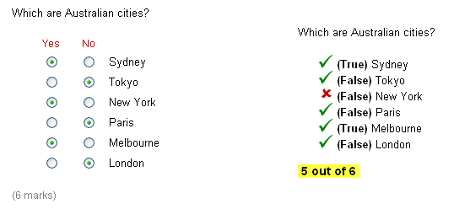
Figure 3: Dichotomous question selections (left) and marked (right).

Figure 3 shows on the left hand side the various choices a user made to the available options. On the right of this figure shows the interface presenting this question marked. New York is not an Australian city and so a red cross is displayed next to it. The emboldened text within the brackets shows the correct answers. So in the case of New York it is meant to be False. Positive marking in employed in Figure 3 so the user receives 5 out of 6.

2.2 Multiple Choice

Presentation

Multiple choice questions allow the examinee to select one answer from a range of options. Between 2 and 12 different options can be included per question and these can be made up of text or other media (graphics, Chime, audio, video). As Figure 4, Figure 5 and Figure 6 show, the system can support a variety of different interface presentation styles. In Figure 4 the options are short and so to save space the examiner has opted to choose horizontal alignment. Figure 5 shows graphical options, in this case safety symbols, that are vertically oriented. Finally, in Figure 6 a dropdown list is used to present the options. In this last case only text can be used as the options – no media formats can be supported.

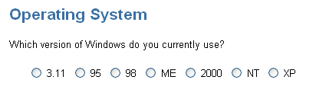
Figure 4: Seven option textual multiple choice question layed out horizontally.

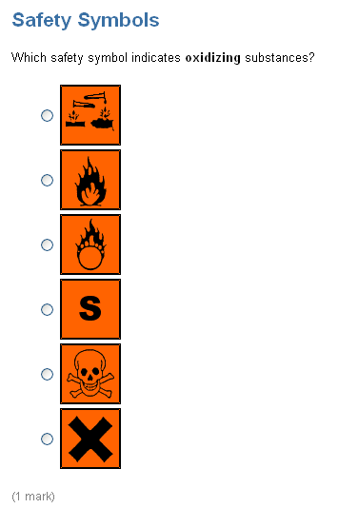
Figure 5: Six option graphical multiple choice question.

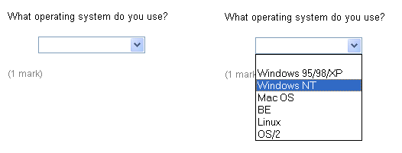
Figure 6: Six option dropdown list multiple choice question.

Marking

One mark is assigned to a correct answer, zero to incorrect answers. Figure 7 shows a graphical multiple choice question that has been marked. In this example the user has selected incorrectly the ‘S’ symbol. A red cross is placed next to this to show that it is wrong. The text ‘Is correct’ is placed next to the burning circle symbol to indicate that it is the correct answer.

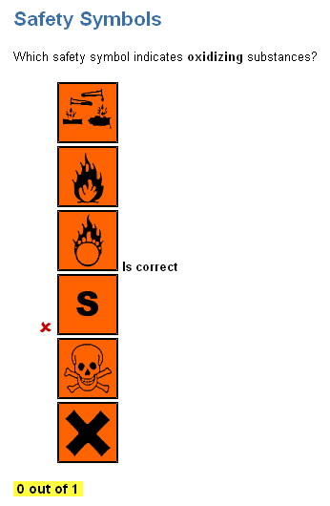
Figure 7: Graphical multiple choice question marked.

2.3 Multiple Response

Presentation

Multiple response questions, like multiple choice questions, contain between 3 and 12 options. However, they differ in that the examinee is asked to select multiple options as part of their answer. In the example shown in Figure 8 the examinee is asked to select 2 of the options displayed. If they try to cheat and simply select all options, after clicking a third a popup warning similar to the one shown in Figure 9 will be displayed. When the user selects ‘OK’ the system will automatically unselect the last option.

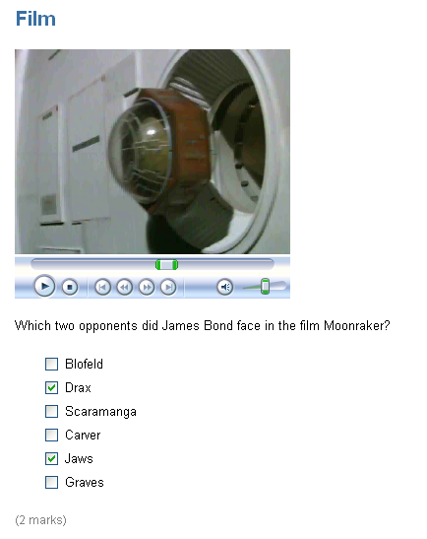
Figure 8: Six option multiple response question using video to augment the textual lead-in.

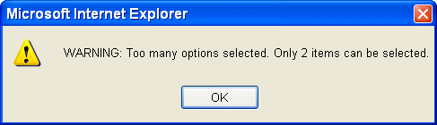
Figure 9: Popup warning if the examinee selects more options than they should.

If an image (GIF, JPEG or PNG) is wider than 600 pixels or higher than 500 pixels then a magnifying glass icon will be displayed beneath it. In such circumstances the image is initially shown at half size with the plus magnifying glass shown. When the user click on this JavaScript automatically resizes the image to the original larger size (i.e. zooms in). At this stage the magnifying glass will change to a minus sign and if clicked again will zoom out by altering the image to half its size again. This method is used so that high resolution X-Ray and other images can be loaded and zoomed without becoming pixelated. Images smaller than 600 pixels width or 500 pixels height will simply be displayed at their normal size and the magnifying glass icon will not be displayed.

Marking

Since there is the risk of an examinee selecting all the checkboxes of a multiple response question, as highlighted above, TouchStone employs two different marking schemes for this type of question:
- One mark is awared per correct answer. So, for example, in Figure 8 the question is marked out of 2. However, in this mode the question writer must specify how many options are expected in the answer. The system will, as seen in Figure 9, display a warning if more options are selected.

- In situations where the question writer does not want to specify how many options should be specified the system will support the marking of all stems. In such circumstances 1 mark is given for each stem if correct. So, for example, if an option should be selected and the examinee has then 1 mark is awarded, but also if an option should be left blank (i.e. inappropriate) and the examinee has left it unchecked then again 1 mark is awarded. If the examinee selects an option that should not or does not select an option which should then the system will take off 1 mark for that stem. Assuming a roughly 50:50 split in the number of correct to incorrect options an examinee checking all options will receive zero marks.

2.4 Extended Matching

Presentation

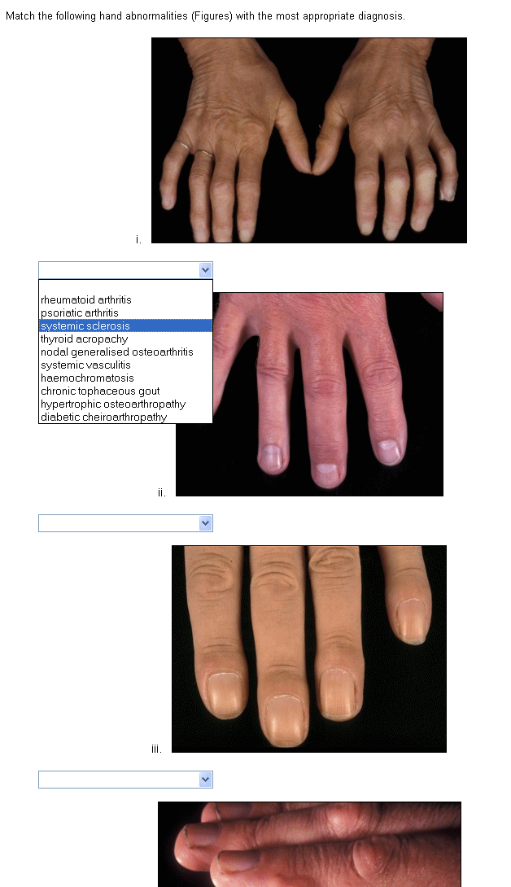
Figure 10: Extended Matching (single response) using graphical instead of the more traditional textual scenarios.

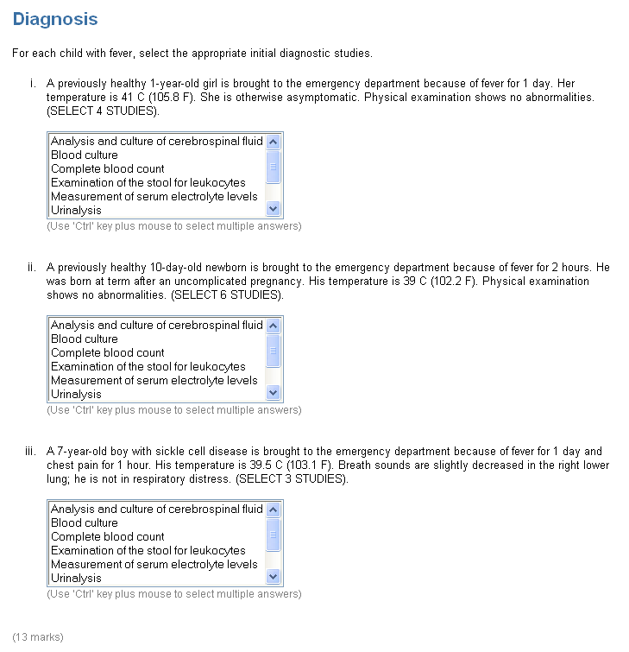
Figure 11: Extended Matching example allowing the examinee to select multiple studies for each of the three clinical scenarios.

2.5 Likert Scale

Presentation

Likert scales will normally be used with surveys, however they can be marked if so desired for assessments. Any number of points on the scale are available from 3 to 10 and the labels at each end, in the case of Figure 12 ‘Disagree’ and ‘Agree’ can be edited by the examiner.

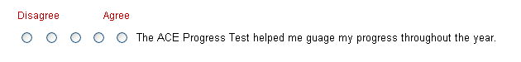
Figure 12: Five point likert scale labelled ‘Disagree’ to ‘Agree’.

Marking

As stated above likert scales would normally be used unmarked in surveys, however in situations where they are included in assessments 1 mark is given for a correct position on the scale and 0.5 marks awarded for neighbouring positions. Zero marks awarded for any other position on the scale.

2.6 Ranking

Presentation

Ranking questions allow the examinee to assign various positions to the range of options presented. In the example shown below in Figure 13 student is being asked to put the planets in the solar system in order starting with the one nearest the sun.

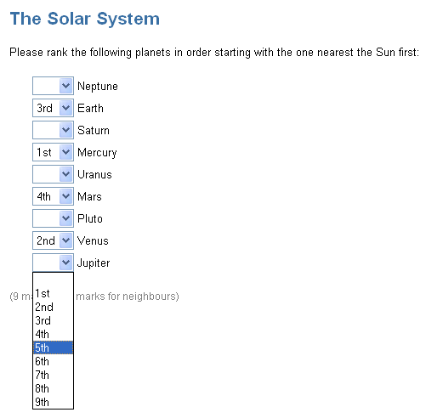
Figure 13: Ranking example using 1 mark per correct option with half marks if the examinee got to within one position of the true order.

Marking

Ranking questions can be marked in four different ways:
- One mark is assigned to each option correctly placed (e.g. Earth = 3rd). No marks are awarded or subtracted for incorrectly ranked options.
- All items must be ranked in the correct order for the allocation of one mark. If any item is not in the correct order then zero is awarded.
- The example in Figure 11 has half marks for correct neighbouring positions. In this mode the system will award 0.5 marks if the examinee put Earth as 2nd or 4th. This allows an examiner to award marks if the overall pattern of a student’s responses roughly correct.
- Ranking only selected options with a bonus mark for correct order. This mode is useful in medicine when it is useful to present the student with a range of different options but only ask them to rank the top three most important (see Figure 14). In this mode the system will assign 1 mark for each correctly selected option (independent or correct rank). This marking scheme is the same as multiple response. However, if the examinee got all the correct responses in the correct order as well then they are assign an extra bonus mark worth one point.

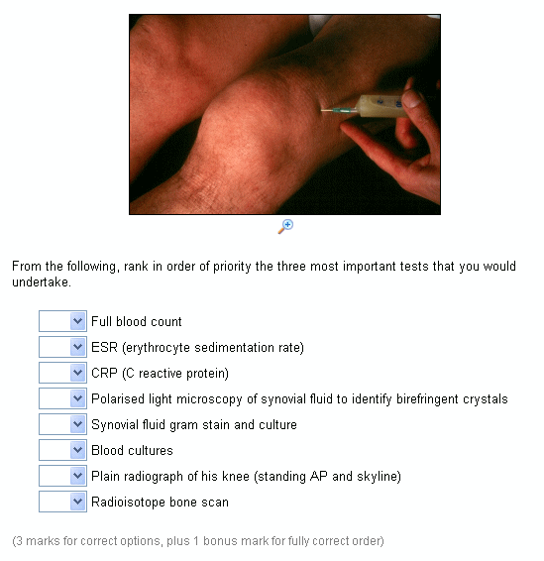
Figure 14: Ranking example using the bonus mark method with a number of distracters which are not to be ranked.

2.7 Fill-in-the-Blank

Presentation

Fill-in-the-blank questions require the examinee to select a correct option for each blank within a paragraph(s) of text (see Figure 15). Because of the difficulty associated with computers marking free-text input boxes (spelling mistakes, synonyms, etc), TouchStone has a dropdown list version of this question type. The examiner writes the question and included the correct answer for each blank (e.g. Cretaceous) together with a number of distracters (e.g. Triassic and Jurassic). The order of all options is randomised within each dropdown list each time the question is displayed.

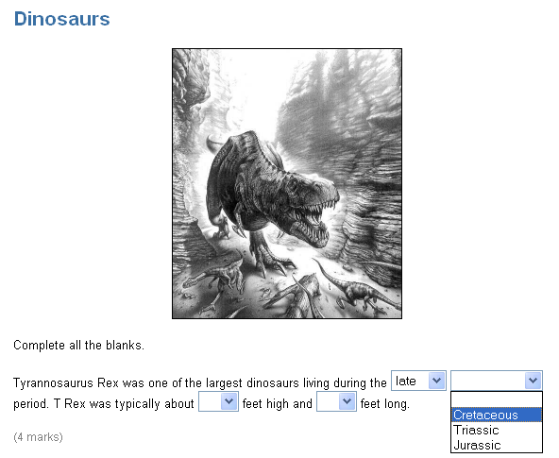
Figure 15: Fill-in-the-Blank question using dropdown lists for each blank.

Marking

One mark is awarded for each blank correctly answered. As Figure 16 shows, a tick or a cross is inserted next to each blank to indicate if the examinee got it right or wrong. If they got it wrong the correct answer is displayed in brackets emboldened (e.g. ‘Late’ Cretaceous).

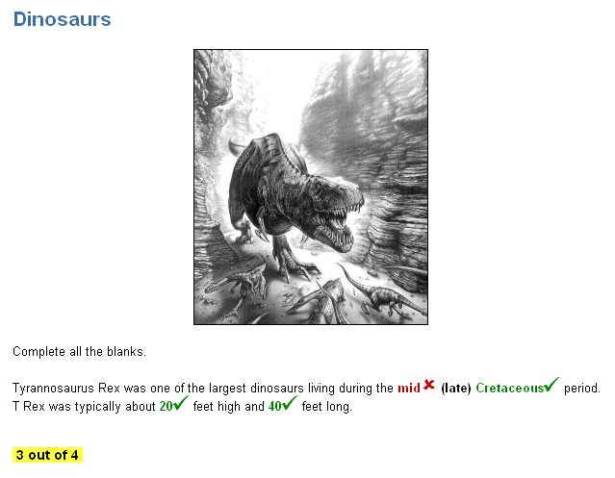
Figure 16: Fill-in-the-Blank marked.

2.8 Image Hotspots

Image hotspots require the Flash plug-in for the browser that is currently being used to access TouchStone.

Presentation

Image hotspots are a useful way of asking a student if they can identify a certain feature of an image. In the example shown in Figure 17 a photograph of the winning podium at the 2004 Australian Grand Prix is displayed. The student is asked to click on Michael Schumacher within the graphic. When the mouse is clicked over the image a small blue circle is displayed indicating the recorded answer. If the user decides to change their answer before submitting the current screen then they can click again on a different part of the image and the blue dot will move.

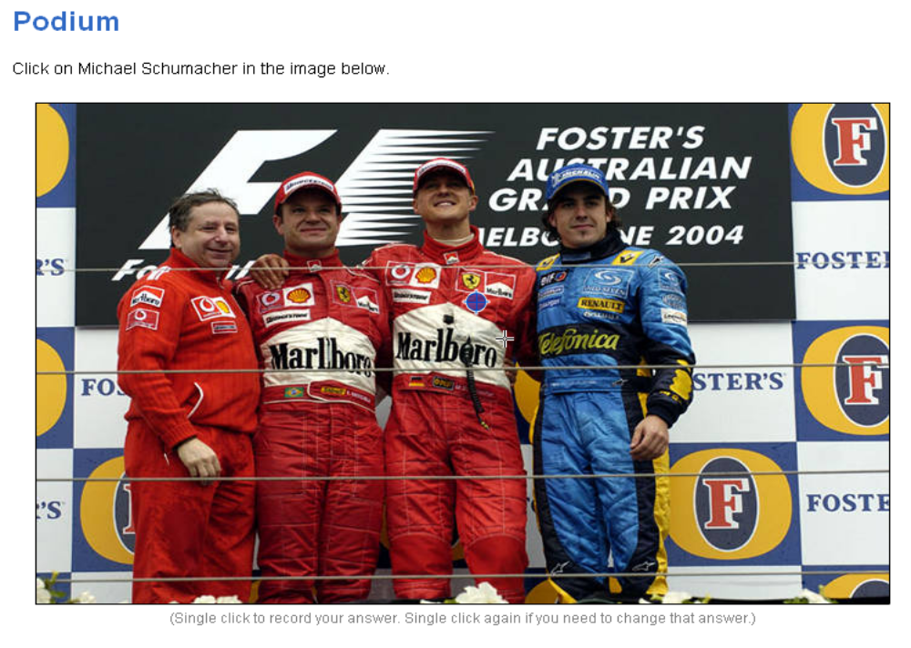
Figure 17: Image hotspot presented. The blue circle indicates where the
user clicked to record their answer.

Marking

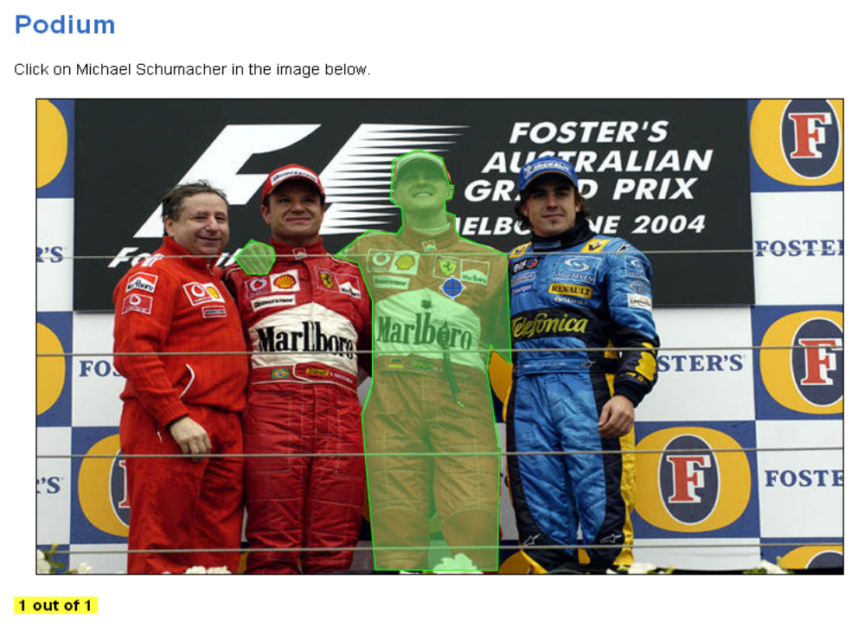
Figure 18: The marked image hotspot. The green shaded areas indicate the correct answer, a click anywhere inside such zones receives the full marks for that question.

3.0 Creating Assessments

3.1 Creating new Questions

New questions can be created by any member of staff by selecting ‘Create new Question’ from the ‘Question Bank Tasks’ menu. A popup menu will be displayed, as shown in Figure 19 listing all the available types of questions that the system supports. Clicking on a specific type of question takes the question writer to an add interface specific to that question type.

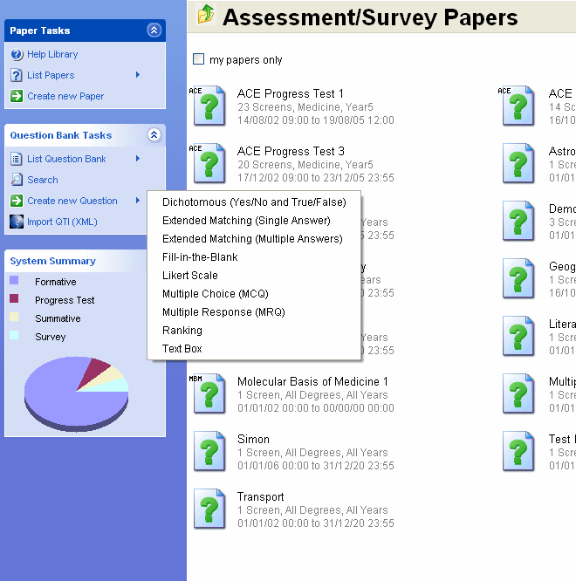
Figure 19: Popup menu showing all the different types of questions that can be created.

Although the add interface differs slightly according to the type of question being added, there is nevertheless many common features. For example, all question types can have a theme, supporting media, clinical scenario, lead-in, notes, keywords and learning outcomes. The add interface for a multiple choice question can be seen in Figure 20.

When all the necessary fields are complete and the question writer click on the ‘Add Questions’ button at the bottom of the screen the system will create a new set of records in the question database and upload any specified media. This question is now in the Question Bank but as yet unassigned to a specific assessment or survey paper.
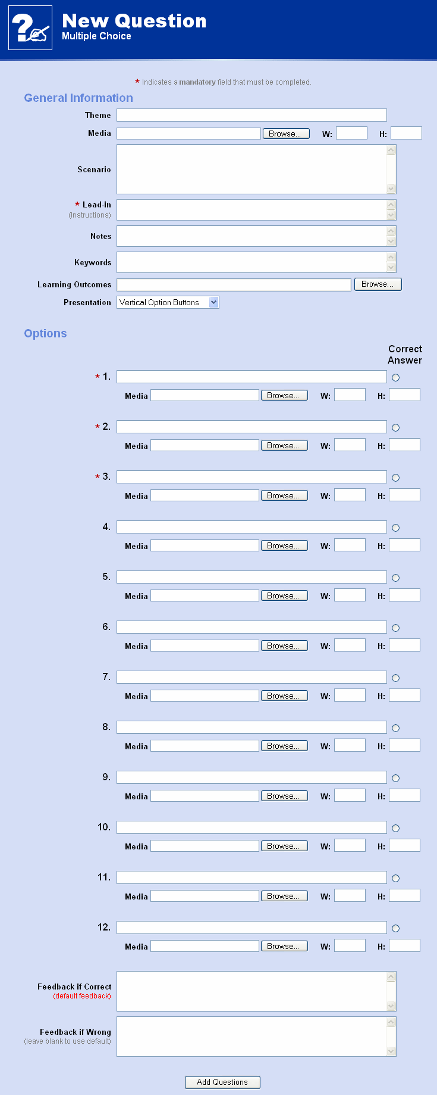 | Figure 20: Add interface for a multiple choice question.
To add a newley created question to an existing paper the examiner should first select a relevant paper to work on. To display a list of the papers the ‘List Papers’ option in the ‘Paper Tasks’ menu should be selected. Once a paper is selected the menu will change to include a ‘Current Paper Tasks’ menu. From here the ‘Add questions to Paper’ link can be selected and a list of questions, similar to those in Figure 21, will be displayed. By default screen shows all questions in the Question Bank that are currently unassigned to any paper.

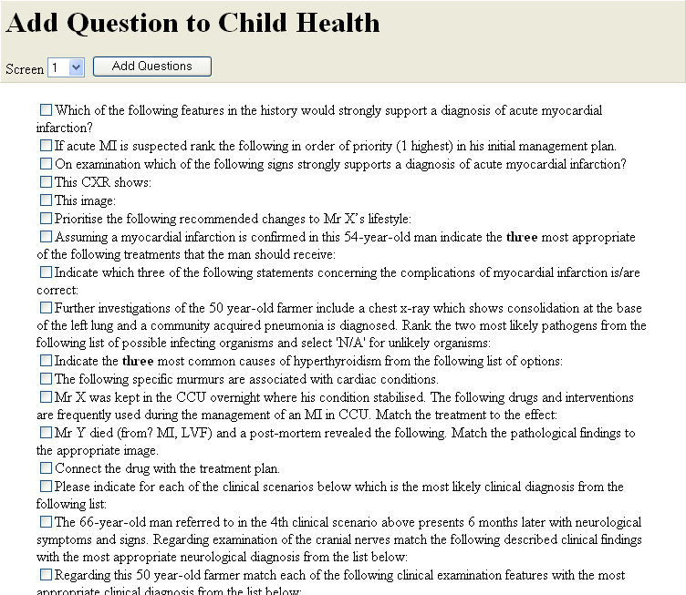
Figure 21: List of questions which can be added to the ‘Child Health’ paper.

3.2 Creating new Papers

To create a new paper (assessment or survey) there must first be at least one available question in the question bank. If there is not a new question must be added (see Section 3.1 above). To start adding a new paper select ‘Create new Paper’ from the ‘Paper Tasks’ menu. A form similar to the one in Figure 22 will be displayed which will allow the examiner to set a paper name or title (must be unique), the type of the assessment (formative, progress test, summative or survey), which candidates are allowed to sit the paper (i.e which degree programmes), which year of study and finally the time and date when this new paper will be available from and to. The prologue text will be displayed at the start of a paper at the top of screen 1 while the postscript will be displayed on the final screen after the student has finished. Display can be set to full-screen (IE only) or windowed and the colours for the paper background/foreground, themes and labels/notes can be alter by either entering a hexadecimal colour code or by clicking on the icons on the right and then selecting a colour from the pop-up colour pallet. When all the relevant details have been set the paper writer should click the ‘Next >’ button.

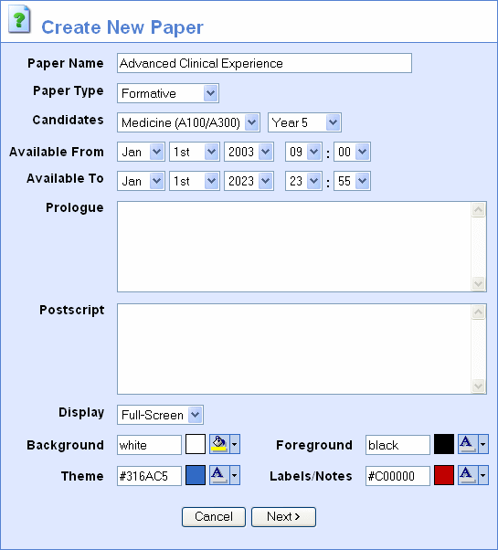
Figure 22: Setting the properties of a new paper.

Having successfully set the properties of the paper a list of available questions from the Question Bank will be displayed which is the same as adding questions to an existing paper (see Figure 21). Select (check) the relevant questions, set the screen number they will appear on and then click ‘Add Questions’.

4.0 Marking and Statistics

4.1 Introduction

Currently two reports are available regarding a cohorts’ responses to a paper: 1) class totals and 2) item analysis. As Figure 23 shows, the examiner must select a start date/time and an end date/time to define the time boundaries of the investigation. Having set the date/times one of the two links below may be selected.

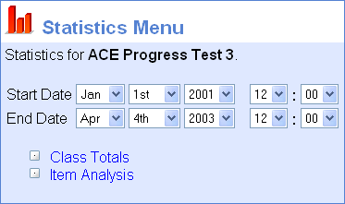
Figure 23: Statistics menu options.

4.2 Class Totals

The ‘class totals’ report displays, as shown in Figure 24, one line per examinee (ordered by examinee’s last name) listing the following information: Examinee last name followed by initials, NLE username, raw mark, adjusted percentage, start time, total duration and IP address of the workstation the paper was taken at. In the case of the ‘ACE Progress Test 3’ paper shown in Figure 24 the raw mark is an unadjusted total number of marks awared to the examinee for this paper. In this case the paper was marked out of a total of 200 marks. The ‘adjusted percentage’ column takes this raw mark and subtracts the ‘expected mark’ from the examinee’s mark and displays this as a percentage out of the total number of marks possible on the paper minus the expected mark. This adjusting is particularly important in the absence of negative marking where there is a statistical probability of selecting the correct answer purely by chance. For example, a True/False question worth 1 mark would have an expected mark of 0.5 marks. A four option MCQ question worth 1 mark would have an expected mark of 0.25 and so on. These probabilities are all calculated automatically by the system. The expected mark is not calculated for any questions that are set in negative marking mode.

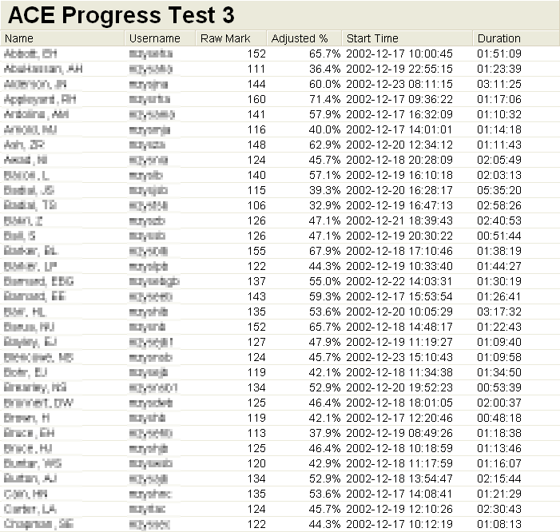
Figure 24: Class totals for assessment ‘ACE Progress Test 3’.

At the bottom of the ‘class totals’ report a number of summary charts are displayed. As shown in Figure 25 a distribution bar chart shows adjusted percentage mark against occurrence. Percentages below 40% are displayed in red to indicate failures. Below this bar chart is a scatter plot showing adjusted percentage mark against time in minutes. Again, marks below 40% are displayed in red. Below the charts some quantitative summaries are presented: number of students submitted, total marks for the paper, the calculated expected mark, average raw mark and average adjusted percentage, standard deviation of the raw mark, maximum raw mark, minimum raw mark and the average time taken to complete the paper.

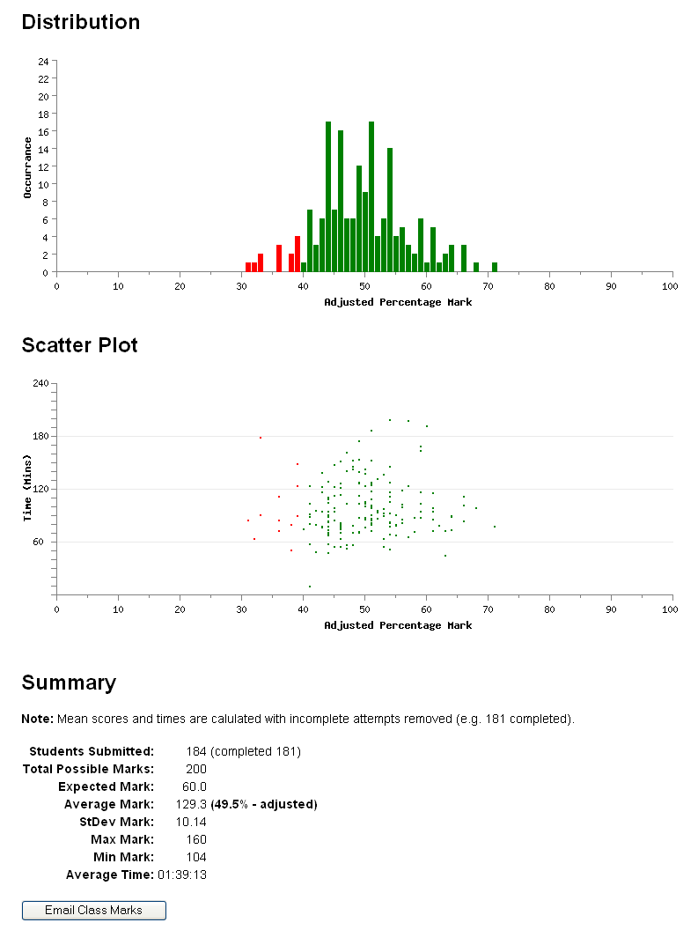
Figure 25: Continuation of Figure 25 (bottom of screen).

4.3 Item Analysis

5.0 Searching

TouchStone provides for the full-text search of any combination of the following fields: theme, scenario, lead-in, options and keywords.

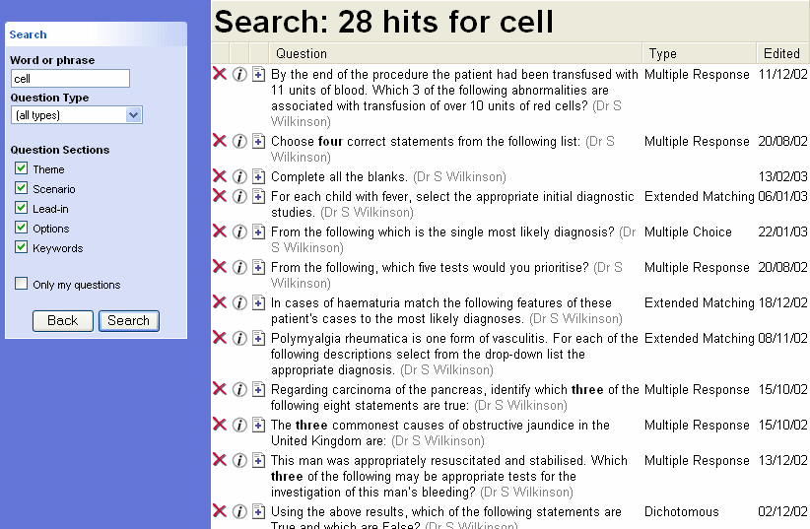
Figure 26: Search options (left) together with results (right).

Figure 26 shows the results of running a search for the keyword ‘cell’ across all the question table fields (theme, scenario, lead-in, etc.). The first icon, a red cross displayed on the left hand side of each line, is an option to delete the current question. This will delete the original question from the question bank. If the question is already used on one or more papers a warning will be displayed stopping the examiner from taking this deletion action. In these circumstances the question ‘pointer’ would first have to be removed from the paper and then the question itself deleted. A second point to note is that questions may only be deleted by their owner. A grey ‘disabled’ cross icon will be displayed if the currently logged on user does not own any of the found questions.

The next icon from the left, which symbolises an information sign, brings up further details about the relevant question. This information, as can be seen in Figure 27 lists: a) the owner of the question, b) the date/time when the question was originally created, c) the date/time the question was last edited and d) which paper(s) the question is currently used on.
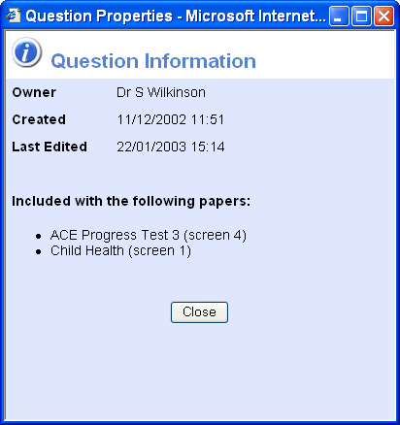
Figure 27: Question details displayed after click on an information icon in Figure 16.

The third icon which looks like a small document symbol with a plus sign on it is used to add newly found questions to an existing paper. Instead of navigating to the desired paper and then selecting ‘Add questions to Paper’ from the menu, this icon will allow an examiner to perform a search for a question and then to quickly add it to a paper. When clicked a ‘Select Paper’ dialog box similar to the one in Figure 28 will be displayed. This will only show a list of papers owned by the current user. Also, papers that are currently ‘active’ (within the current date range), cannot have questions added to them. This is a safety feature so that active papers do not change while students take them. Active papers will be displayed greyed out with a warning icon next to them.

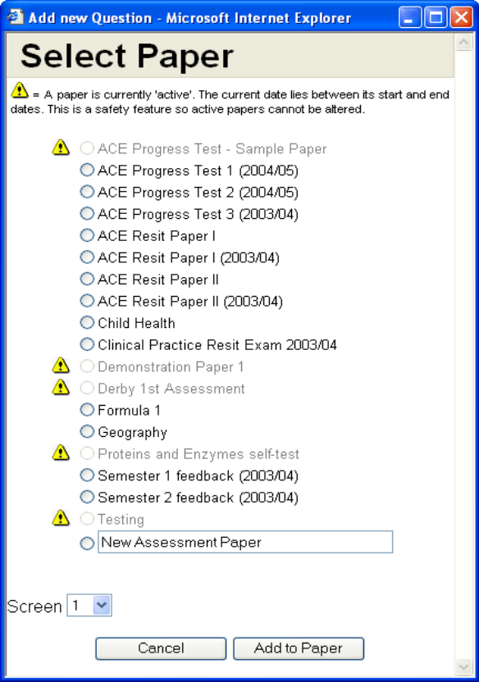
Figure 28: Select paper dialog box.

6.0 Importing/Exporting Questions

6.1 Exporting a Paper

A set of questions may be exported in QTI format by navigating to a paper and then selecting ‘Export as QTI (XML)’ from the ‘Current Paper Tasks’ menu. This will generate an XML formatted document which viewed in Internet Explorer looks like the output in Figure 29. This newly created file may be saved to a local hard disk by selecting the ‘File’ pulldown menu in Internet Explorer and choosing ‘Save As…’.

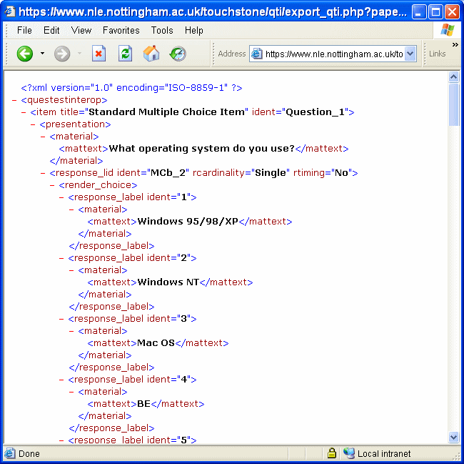
Figure 29: Exported questions displayed in QTI XML format in Internet Explorer.

Note: Currently TouchStone only supports the exporting of MCQ questions in QTILite format. Full QTI capability in the future.

6.2 Importing Questions

Questions can be imported into TouchStone by selecting ‘Import QTI (XML)’ from the main menu. A dialog box similar to the one in Figure 30 will be displayed to allow the examiner to select an XML file containing the questions to be uploaded. When the ‘Import’ button is clicked this file will be uploaded onto the server, parsed automatically for QTI complient syntax, the question bank will be populated with the new questions and then the file deleted from the server.

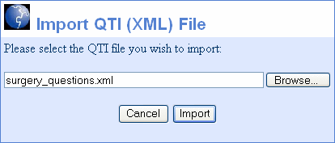
Figure 30: Import QTI File dialog box.

Newly imported questions are uploaded into the question bank at first to allow the examiners at the importing institution to specify which papers they would like to use the questions on. This can be done in the normal manner of adding questions to papers.

Note: Import routine not fully complete. More work required on parsing.

Appendix A – Basic XHTML tags

Function | XHTML code example | Preview
bold | This is a <strong>bold</strong> word. | This is a bold word.
italic | This is an <em>italic</em> word. | This is an italic word.
superscript | 20<sup><small>o</small></sup>C | 20ºC
subscript | H<sub><small>2</small></sub>O | H₂O
background colour | This word will have a <span style=”color: #FFFF00”>yellow  </span> background | This word will have a yellow background
carriage return | Putting in a carriage return<br />makes this on the next line | Putting a carriage return  Makes this on the next line

Questions may only be added to a paper by the current owner of the paper. Also, no questions may be added to a paper by anyone, including the owner, while that paper is available to be sat by examinees.

